Name ______________________________ HOMEWORK Module 1 Week 1
Put your initials by each night that your child practiced the following:
____Monday ____Tuesday ____Thursday
*Nightly Homework*
1. Count numbers 1-25.
2. Practice assigned Sight Word list in red reading folder.

MONDAY-Identifying Words in Sentences: Count the words!
I see the bus. ___ I like school. ___
The bus can go. ___ The school is big. ___
The bus is yellow. ___ I made a friend. ___
I . ____

Point to each letter and say the letter.
A F b c B d
E f e C a D

Read it. Trace it. Write it.
the the ___

TUESDAY- Practice forming the letters.
A a B b C c
D d E e F f
Practice writing your first name two times. Only capitalize the beginning letter. ______________
THURSDAY- Color the box if the pictures rhyme.
can pan
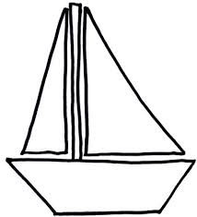
bear boat
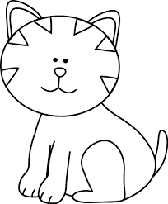
cat hat

cake snake
snake cat

bear chair

